(1) Program Mission

The program aims to cultivate healthcare professionals with international perspectives, interdisciplinary expertise, and competencies in smart health management applications. It responds to global health challenges and the evolving needs of the healthcare industry. By integrating core domains such as geriatric medicine, smart health management, mental health, and long-term care, the program is committed to advancing academic research, industrial applications, and international collaboration to deliver innovative solutions for global healthcare.
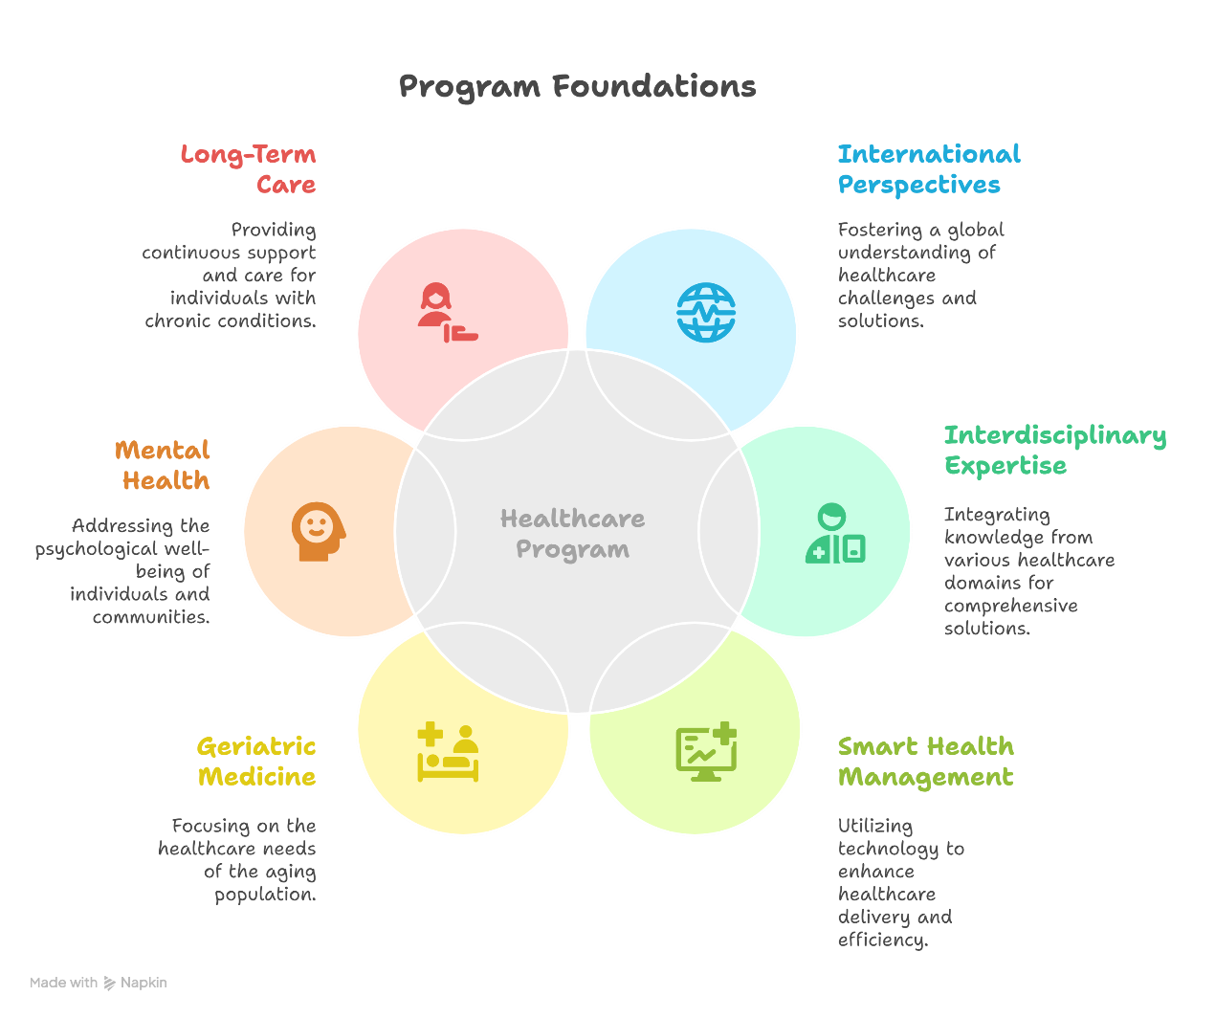

(2) Program Educational Objectives

- Strengthen international collaboration and interdisciplinary learning to cultivate healthcare professionals with global awareness and professional development capabilities.

- Promote the application of smart health technologies and holistic care to enhance healthcare management and service effectiveness.

- Develop expertise in geriatric medicine and long-term care to reinforce competencies in elderly care and mental health support.

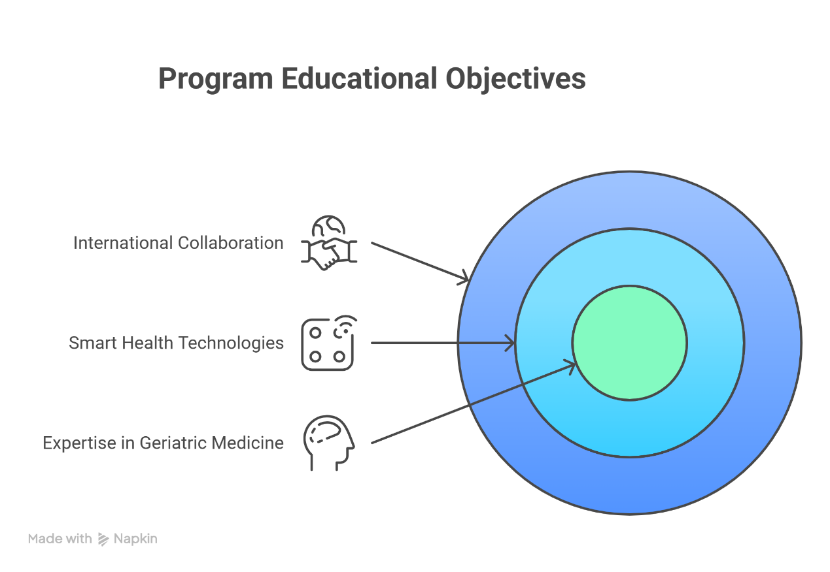
(3) Core Competencies of the Program

- International healthcare literacy and cross-cultural communication skills

- Competence in smart health technology applications and data analytics

- Professional capability in geriatric and long-term care

- Mental health assessment and holistic care ability

- Interdisciplinary integration and problem-solving skills

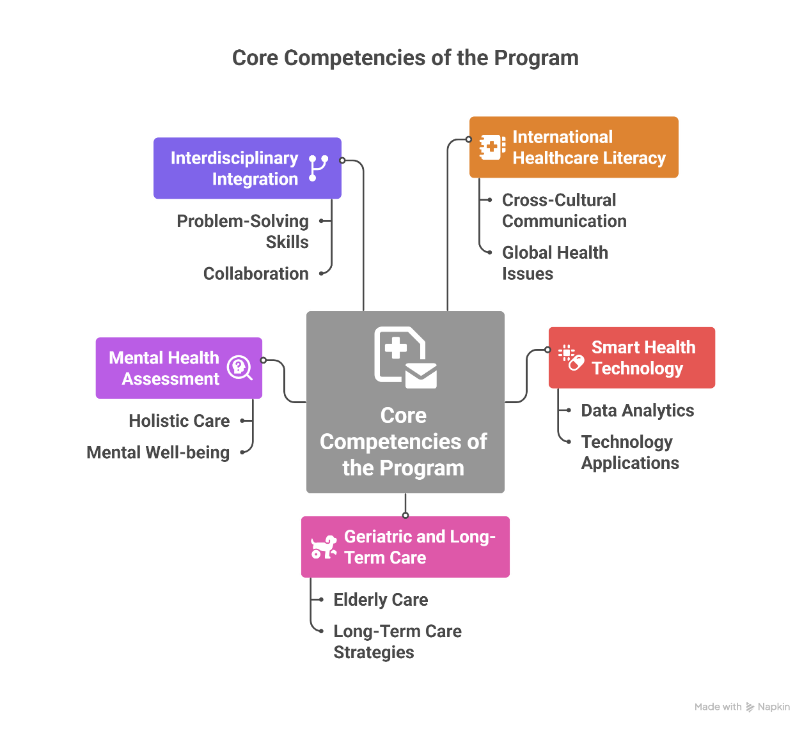
(4) Core Development Directions of the Program

- Strengthening international collaboration:
Enhance global impact through academic exchanges and joint research initiatives, while providing international students with a high-quality learning environment.

- Developing and expanding smart health management curricula:
Reinforce training in data analytics, health information systems, and the application of technology in clinical care to ensure students acquire competencies in emerging technologies.

- Advancing innovative teaching models:
Introduce simulation-based learning, case analysis, and hands-on practicums to improve students’ clinical decision-making abilities and professional competence.
